HTML

Comment HTML

You can start a comment with <!-- and end a comment with -->

Change the Color of Text

<h2 style="color: blue">CatPhotoApp</h2>

Use a CSS Class to Style an Element

Classes are reusable styles that can be added to HTML elements.

Here's an example CSS class declaration:

<style>
.blue-text {
color: blue;
}
</style>

You can see that we've created a CSS class called blue-textwithin the <style> tag.
You can apply a class to an HTML element like this:
<h2 class="blue-text">CatPhotoApp</h2>

Style Multiple Elements with a CSS Class

Remember that CSS class selectors require a period at the beginning like this:
.blue-text {
color: blue;
}

But also remember that class declarations don't use a period, like this:
<h2 class="blue-text">CatPhotoApp</h2>

Change the Font Size of an Element

Font size is controlled by the font-size CSS property, like this:
h1 {
font-size: 30px;
}

Set the Font Family of an Element

You can set an element's font by using the font-familyproperty.
For example, if you wanted to set your h2 element's font to Sans-serif, you would use the following CSS:
h2 {
font-family: Sans-serif;
}

Specify How Fonts Should Degrade

There are several default fonts that are available in all browsers. These include Monospace, Serif and Sans-Serif
When one font isn't available, you can tell the browser to "degrade" to another font.
For example, if you wanted an element to use the Helveticafont, but also degrade to the Sans-Serif font when Helvetica wasn't available, you could use this CSS style:
p {
font-family: Helvetica, Sans-Serif;
}

Add Images to your Website

You can add images to your website by using the imgelement, and point to a specific image's URL using the srcattribute.
An example of this would be:
<img src="https://www.your-image-source.com/your-image.jpg">

All img elements must have an alt attribute. The text inside an alt attribute is used for screen readers to improve accessibility and is displayed if the image fails to load.
Lets add an alt attribute to our img example above:
<img src="https://www.your-image-source.com/your-image.jpg" alt="Author standing on a beach with two thumbs up. ">

<img src="https://bit.ly/fcc-relaxing-cat" alt="A little cat">

Size your Images
CSS has a property called width that controls an element's width. Just like with fonts, we'll use px (pixels) to specify the image's width.
For example, if we wanted to create a CSS class called larger-image that gave HTML elements a width of 500 pixels, we'd use:
<style>
.larger-image {
width: 500px;
}
</style>

Add Borders Around your Elements

For example, if we wanted to create a red, 5 pixel border around an HTML element, we could use this class:
<style>
.thin-red-border {
border-color: red;
border-width: 5px;
border-style: solid;
}
</style>

Remember that you can apply multiple classes to an element by separating each class with a space within its classattribute. For example:
<img class="class1 class2">

Add Rounded Corners with a Border Radius
We can round out those corners with a CSS property called border-radius
EX:
border-radius:15px;

Make Circular Images with a Border Radius
In addition to pixels, you can also specify a border-radiususing a percentage.
Border-radius: 50%;

Link to External Pages with Anchor Elements

a elements, also known as anchor elements, are used to link to content outside of the current page.

Here's an example:
<p>Here's a <a href="http://freecodecamp.org"> link to Free Code Camp</a> for you to follow.</p>

Make Dead Links using the Hash Symbol

Sometimes you want to add a elements to your website before you know where they will link.
Put the value of your a element's href attribute with a #, also known as a hash symbol, to turn it into a dead link.

Example:
<p>Click here for <a href="#">cat photos</a>.</p>

Turn an Image into a Link
<a href="#"><img src="https://bit.ly/fcc-running-cats" alt="Three kittens running towards the camera. "></a>

Create a Bulleted Unordered List
Unordered lists start with a <ul> element. Then they contain some number of <li> elements.
Like:
<ul>
<li>milk</li>
<li>cheese</li>
</ul>

Create an Ordered List
Ordered lists start with a <ol> element. Then they contain some number of <li> elements.

Like
<ol>
<li>Garfield</li>
<li>Sylvester</li>
</ol>

Create a Text Field

Text inputs are a convenient way to get input from your user.
You can create one like this:
<input type="text">
Note that input elements are self-closing.



Placeholder

placeholder est un attribut qui permet de renseigner un texte indicatif par défaut dans un champ de formulaire.
C'est une valeur qui s'efface dès que l'utilisateur active le champ de formulaire (ou commence à écrire dedans si vous êtes sous Webkit).
Syntaxe
<input type="text" placeholder="Entrez un pseudo">



Create a Form Element

The HTML <form> element defines a form that is used to collect user input:

<form action="/action_page.php">
First name:<br>
<input type="text" name="firstname" value="Mickey">
<br>
Last name:<br>
<input type="text" name="lastname" value="Mouse">
</form>

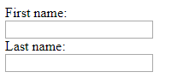

Add a Submit Button to a Form
Let's add a submit button to your form. Clicking this button will send the data from your form to the URL you specified with your form's action attribute.
Here's an example submit button:
<button type="submit">this button submits the form</button>

Use HTML5 to Require a Field
You can require specific form fields so that your user will not be able to submit your form until he or she has filled them out.
For example, if you wanted to make a text input field required, you can just add the word required within your inputelement, you would use: <input type="text" required>

Create a Set of Radio Buttons

You can use radio buttons for questions where you want the user to only give you one answer.

Each of your radio buttons should be nested within its own label element.
All related radio buttons should have the same nameattribute.

<form>
<input type="radio" name="gender" value="male" checked> Male<br>
<input type="radio" name="gender" value="female"> Female<br>
<input type="radio" name="gender" value="other"> Other
</form>
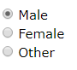

Create a Set of Checkboxes

Forms commonly use checkboxes for questions that may have more than one answer.
Checkboxes are a type of input
Each of your checkboxes should be nested within its own label element.
All related checkbox inputs should have the same nameattribute.
Here's an example of a checkbox:
<label><input type="checkbox" name="personality"> Loving</label>

C'est comme les radio mais sous forme carrée “ check”

Check Radio Buttons and Checkboxes by Default
You can set a checkbox or radio button to be checked by default using the checked attribute.
To do this, just add the word "checked" to the inside of an input element. For example:
<input type="radio" name="test-name" checked>

Nest Many Elements within a Single Div Element

Adjusting the Padding of an Element

Padding: marge extérieure entre le texte et la bordure

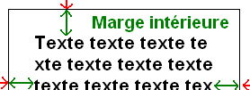

This property can have from one to four values.
Examples:
- padding:10px 5px 15px 20px;
  - top padding is 10px
  - right padding is 5px
  - bottom padding is 15px
  - left padding is 20px
padding:10px 5px 15px;
  - top padding is 10px
  - right and left padding are 5px
  - bottom padding is 15px

- padding:10px 5px;
  - top and bottom padding are 10px
  - right and left padding are 5px

- padding:10px;
  - all four paddings are 10px
Note: Negative values are not allowed.

Adjust the Margin of an Element

C'est la marge extérieure entre un rebord et un autre.

The margin shorthand property sets all the margin properties in one declaration. This property can have from one to four values.
Examples:
- margin:10px 5px 15px 20px;
  - top margin is 10px
  - right margin is 5px
  - bottom margin is 15px
  - left margin is 20px

- margin:10px 5px 15px;
  - top margin is 10px
  - right and left margins are 5px
  - bottom margin is 15px

- margin:10px 5px;
  - top and bottom margins are 10px
  - right and left margins are 5px

- margin:10px;
  - all four margins are 10px
Note: Negative values are allowed.

Add a Negative Margin to an Element

If you set an element's margin to a negative value, the element will grow larger.

Add Different Padding to Each Side of an Element

Sometimes you will want to customize an element so that it has different padding on each of its sides.
CSS allows you to control the padding of an element on all four sides with padding-top, padding-right, padding-bottom, and padding-left properties.

.red-box {
background-color: red;
padding-top: 40px;
padding-right: 20px;
padding-bottom: 20px;
padding-left: 40px;
}

Add Different Margins to Each Side of an Element

.red-box {
background-color: green;
margin-top: 40px;
margin-right: 20px;
margin-bottom: 20px;
margin-left: 40px;
}

Use Clockwise Notation to Specify the Padding of an Element

Instead of specifying an element's padding-top, padding-right, padding-bottom, and padding-left properties, you can specify them all in one line, like this:
padding: 10px 20px 10px 20px;

Use Clockwise Notation to Specify the Margin of an Element

Instead of specifying an element's margin-top, margin-right, margin-bottom, and margin-left properties, you can specify them all in one line, like this:
margin: 10px 20px 10px 20px;

Prioritize One Style Over Another

Sometimes your HTML elements will receive multiple styles that conflict with one another.
For example, your h1 element can't be both green and pink at the same time.
Let's see what happens when we create a class that makes text pink, then apply it to an element. Will our class override the body element's color: green; CSS property?
Create a CSS class called pink-text that gives an element the color pink.
Give your h1 element the class of pink-text.

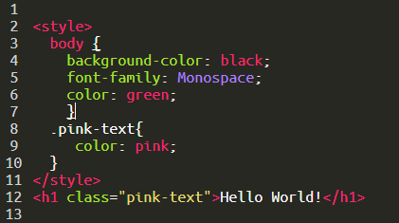

Override Styles in Subsequent CSS

We just proved that our classes will override the bodyelement's CSS. So the next logical question is, what can we do to override our pink-text class?

Applying multiple class attributes to a HTML element is done with a space between them like this:
class="class1 class2"
Note: It doesn't matter which order the classes are listed in the HTML element.
However, the order of the class declarations in the <style> section are what is important. The second declaration will always take precedence over the first. Because .blue-text is declared second, it overrides the attributes of .pink-text
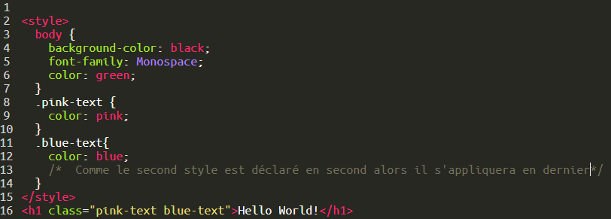

Override Class Declarations by Styling ID Attributes

We just proved that browsers read CSS from top to bottom. That means that, in the event of a conflict, the browser will use whichever CSS declaration came last.

Let's override your pink-text and blue-text classes, and make your h1 element orange, by giving the h1 element an id and then styling that id.
Give your h1 element the id attribute of orange-text. Remember, id styles look like this:
<h1 id="orange-text">
Leave the blue-text and pink-text classes on your h1element.
Create a CSS declaration for your orange-text id in your style element. Here's an example of what this looks like:
#brown-text {
color: brown;
}
Note: It doesn't matter whether you declare this css above or below pink-text class, since id attribute will always take precedence.

Override Class Declarations with Inline Styles

So we've proven that id declarations override class declarations, regardless of where they are declared in your style element CSS.
There are other ways that you can override CSS. Do you remember inline styles?
Use an in-line style to try to make our h1 element white. Remember, in line styles look like this:
<h1 style="color: green">
Leave the blue-text and pink-text classes on your h1element.

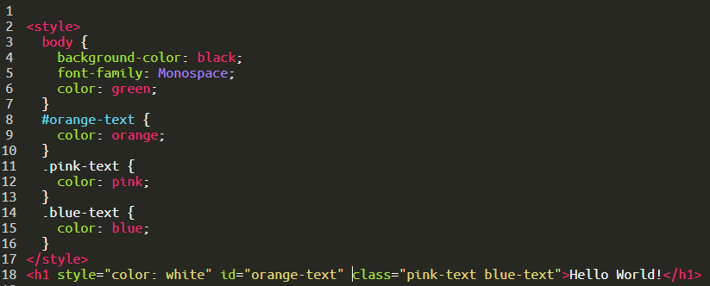

Override All Other Styles by using Important

Yay! We just proved that in-line styles will override all the CSS declarations in your style element.
But wait. There's one last way to override CSS. This is the most powerful method of all. But before we do it, let's talk about why you would ever want to override CSS.
In many situations, you will use CSS libraries. These may accidentally override your own CSS. So when you absolutely need to be sure that an element has specific CSS, you can use !important

Let's add the keyword !important to your pink-text element's color declaration to make 100% sure that your h1element will be pink.
An example of how to do this is:
color: red !important;

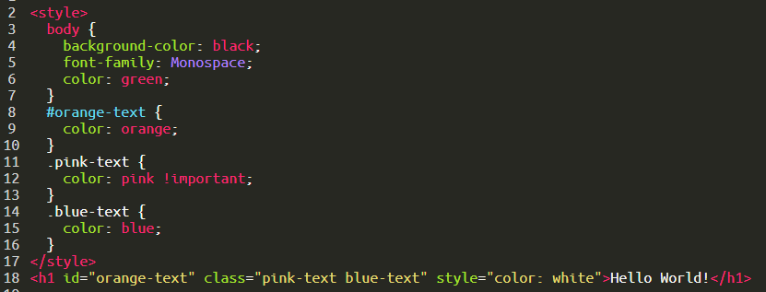

Use Hex Code for Specific Colors

Did you know there are other ways to represent colors in CSS? One of these ways is called hexadecimal code, or hex code for short.

In CSS, we can use 6 hexadecimal digits to represent colors, two each for the red (R), green (G), and blue (B) components. For example, #000000 is black and is also the lowest possible value

<style>
body {
background-color: #000000;
}
</style>

Use Abbreviated Hex Code
For example, red's hex code #FF0000 can be shortened to #F00. This shortened form gives one digit for red, one digit for green, and one digit for blue.
This reduces the total number of possible colors to around 4,000. But browsers will interpret #FF0000 and #F00 as exactly the same color.
Use RGB values to Color Elements
Another way you can represent colors in CSS is by using RGBvalues.
The RGB value for black looks like this:
rgb(0, 0, 0)
The RGB value for white looks like this:
rgb(255, 255, 255)
Instead of using six hexadecimal digits like you do with hex code, with RGB you specify the brightness of each color with a number between 0 and 255.
If you do the math, the two digits for one color equal 16 times 16, which gives us 256 total values. So RGB, which starts counting from zero, has the exact same number of possible values as hex code.
For black color:
<style>
body {
background-color: rgb(0, 0, 0);
}
</style>

Use RGB to Mix Colors
you can mix colors in RGB by using combinations of different values.
<style>
.red-text {
color: rgb(255, 0, 0);
}
</style>

<h1 class="red-text">I am red!</h1>

